Nutcache - GitHub Integration

Follow these steps to enable nutcache version control integration with GitHub.

1. Click the integration icon to begin.

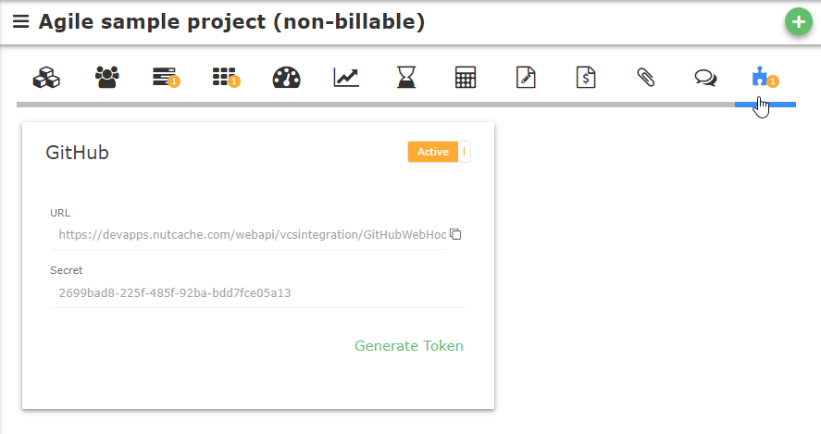

1. Click the toggle button to activate GitHub integration.
2. Nutcache automatically generates the web hook url and the secret needed to complete the integration in GitHub. These values can be changed if needed.
3. In GitHub go to settings option for your repository

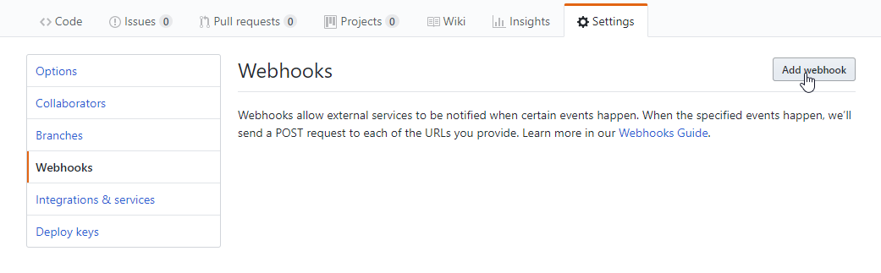

1. Click Add webhook
2. Complete the form with the url and secret supplied by nutcahce.

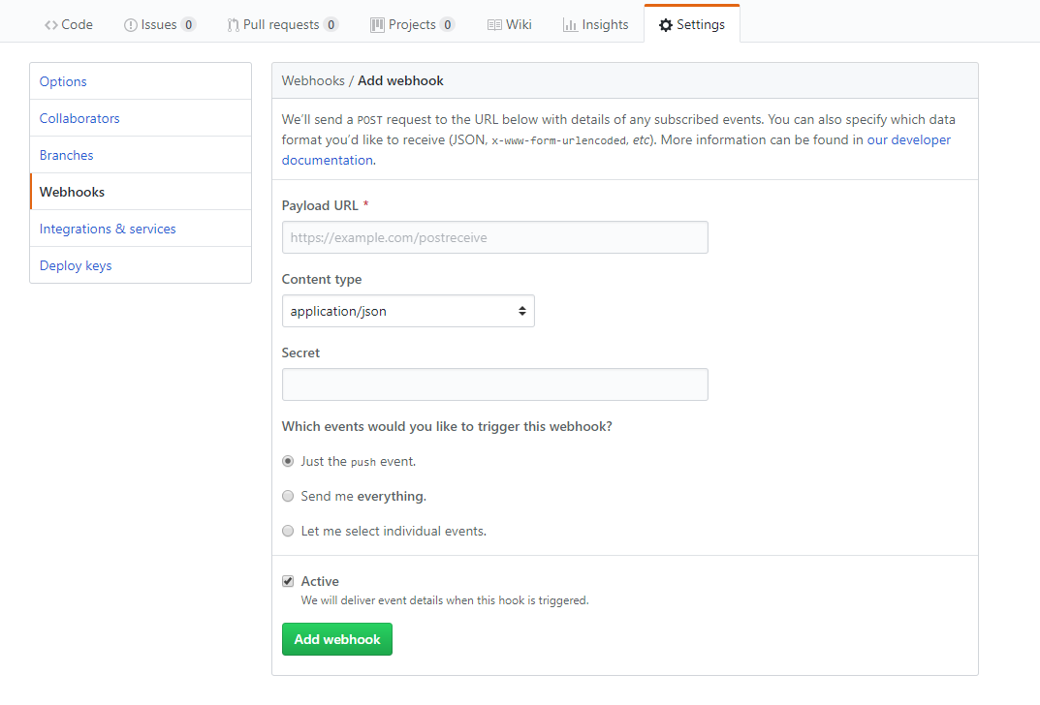

1. Make sure Content type is application/json
2. Customize the level of notifications desired



Click Add webhook and you are done.